Appendix 6.0 – Mount Albert Floor Plan
Emergency Exit Plan for Main Office
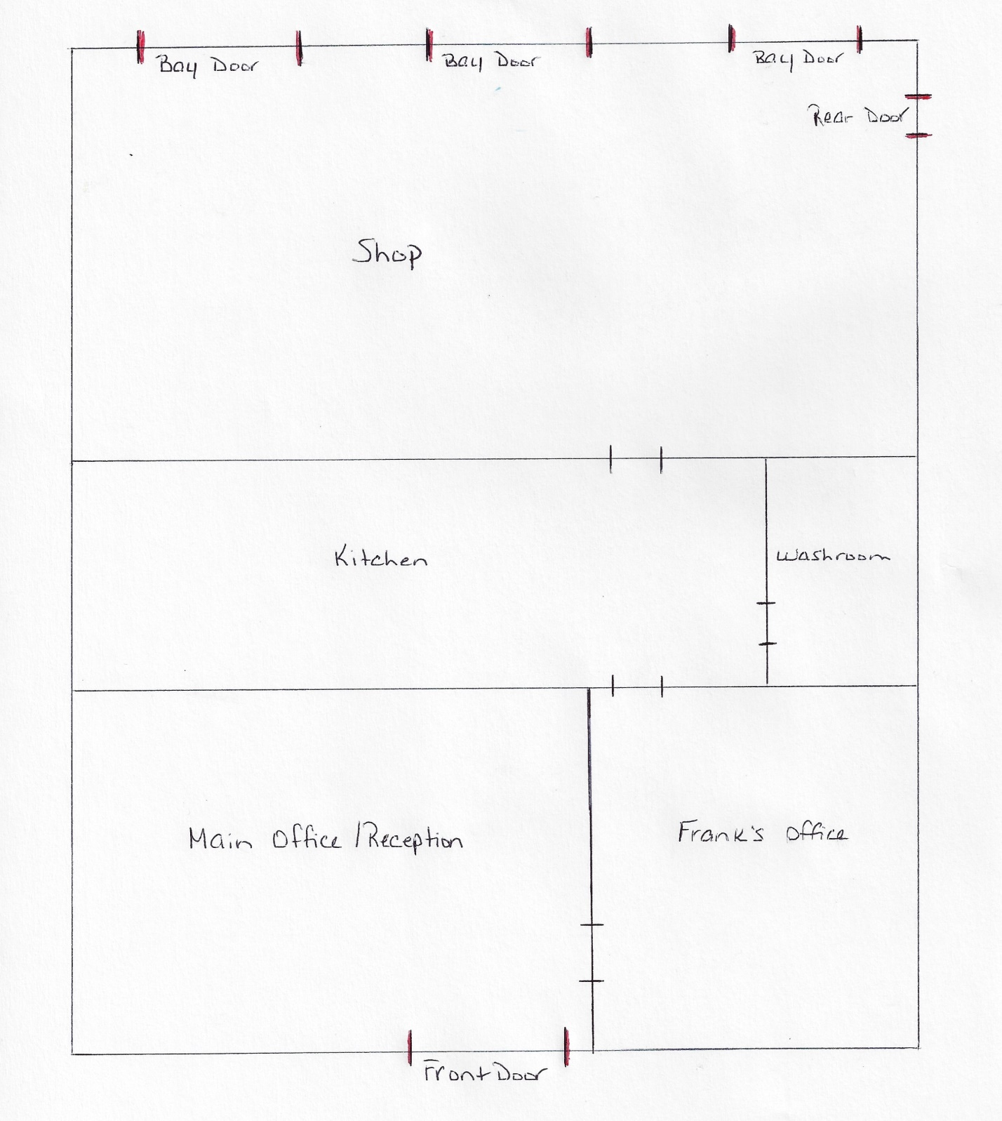
Fire Exits are marked in Red (Front Door, Rear Door or any Bay Door)
Assembly Area – East Side of Office Building (Owner’s Home)

